Themes female cycle

- Stages of the menstrual cycle
- Four main hormones of the female cycle
- What you should know about ovulation
- Ovulation tests at home
- cervical mucus
- Basal body temperature
- Sanitary towels, tampons & Co.
- Relief from period pain
- spotting
- The toxic shock syndrome
- Folic acid & Co.
- lubricant
- Alcohol and fertility
- Late period

Topics fertility treatment

- Types of fertility treatments
- What happens in a fertility clinic?
- Reimbursement of the cost of fertility treatments
- Abbreviations on social media
- pregnancy tests
- Thyroid disorder
- bleeding disorder
- NK cells and plasma cells
- Fallopian tube blockage
- ovarian cysts
- endometriosis
- PCOS
- Rh factor
- Increase in fertility
- Implantation bleeding

MENÜ | KALENDER | BEHANDLUNGSPLAN | TAGEBUCH | ARTIKEL

Relief from period pain

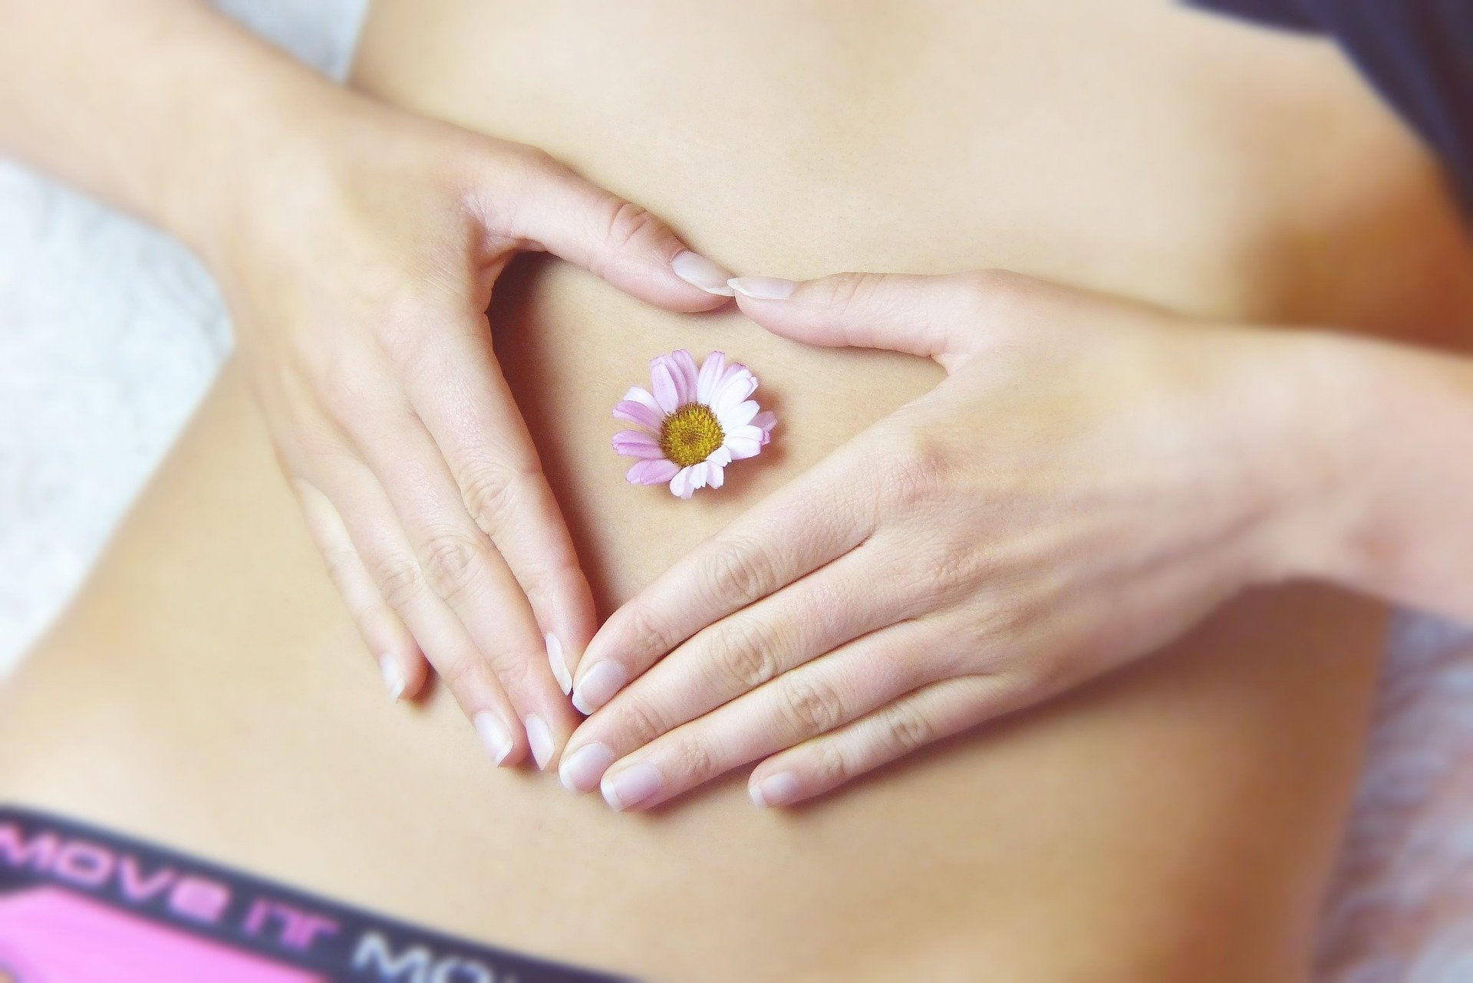

Many women experience abdominal pain just before and / or during their period that can reach their lower back. They are caused by the contraction of the uterus, which sheds the mucous membrane. I've put together a few tips here that can relieve the pain.

- Warmth can provide relief. Whether you take a soothing bath or put a warming pillow on your stomach, both help. The warmth relaxes and releases the tension in your stomach.

- A relaxing massage with essential aromatic oils (chamomile, fennel, marjoram) is good for the stomach. Simply mix a few drops of the oils with massage oil, spread them on your stomach and massage very gently around the navel.

- Warm herbal teas can stimulate the relaxation of the uterine muscles and thus relieve period pain. Some plants / herbs are good home remedies for menstrual cramps, such as lavender, monk's pepper, St. John's wort, chamomile flowers and lemon balm.

- Since you not only lose blood but also fluid during your period, you should drink enough water (at least 2 liters). This will thin your blood and relieve the cramps in your abdomen.

- Even if you would like to crawl into bed with a hot water bottle during your period, a little exercise is good for abdominal and back pain. Light physical activity, such as walking or yoga, can stimulate blood flow in the pelvis and relieve cramps. For the time being, you should avoid strenuous activities such as competitive sports or weight training.

- Over-the-counter pain relievers can help relieve abdominal and back pain. Always pay attention to the package insert regarding tolerability.

MENÜ | KALENDER | BEHANDLUNGSPLAN | TAGEBUCH | ARTIKEL

